The amount of weight you gain during pregnancy is important for the health of your pregnancy and for the long-term health of you and your baby. Learn about pregnancy weight gain recommendations and steps you can take to meet your pregnancy weight gain goal.
How much weight should you gain during pregnancy?
How much weight you should gain during your pregnancy is based on your body mass index (BMI) before pregnancy. BMI is measured of body fat calculated from weight and height.
Calculate you BMI and weight category using your weight from before you became pregnant:
Weight Gain Recommendations For Women Pregnant With One Baby
If Before Pregnancy, you You Should Gain Were…
Underweight
BMI less than 18.5 28-40 pounds
Normal Weight
BMI 18.5-24.9 25-35 pounds
Overweight
BMI 25.0-29.9 15-25 pounds
Obese
BMI greater than or equal 11-20 pounds to 30.0
What Percentage of Women Are Within Pregnancy Weight Gain
Recommendations?
Recent studies found that only about one-third (32%) of women gained the recommended amount of weight during pregnancy and most women gained weight outside the recommendations (21% too little, 48% too much).
Percentage of Women Below, Within, and Above Pregnancy Weight Gain
Recommendations
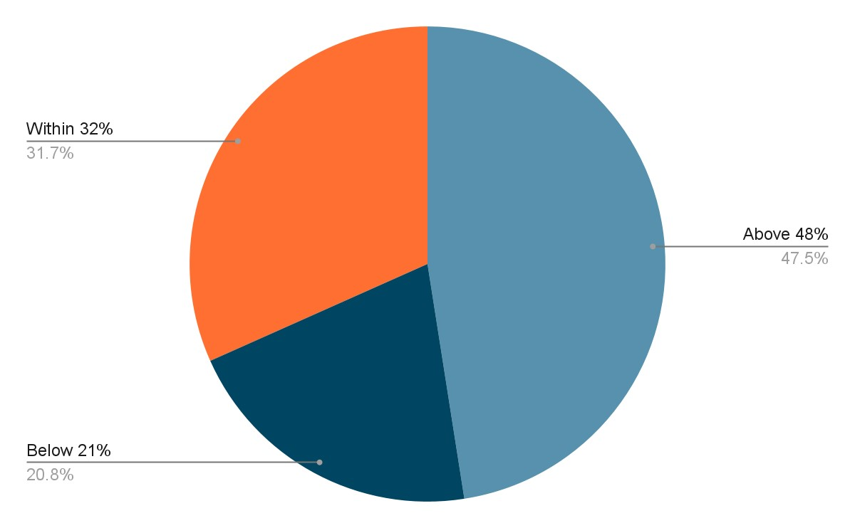
Source: 2015 National Vital Statistics System birth data. https://www.cdc.gov/nchs/nvss/births.htm,
For more information, please visit
https://www.cdc.gov/mmwr/volumes/65/wr/mm6540a10.htm
Why Is It Important to Gain the Recommended Amount of Weight During Pregnancy?
Gaining less than the recommended amount of weight during pregnancy is associated with delivering a baby who is too small. Some babies born too small may have difficulty starting breastfeeding, may be at an increased risk for illness, and may experience developmental delays (not meeting the milestones for his or her age).
Gaining more than the recommended amount of weight in pregnancy is associated with having a baby who is born too large, which can lead to delivery complications, cesarean delivery, and obesity during childhood. Gaining more than the recommended amount of weight can also increase the amount of weight you hold on to after pregnancy, which can lead to obesity.

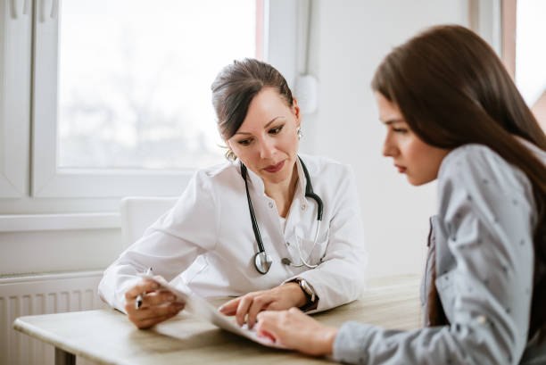
What Steps Can You Take to Meet Pregnancy Weight Gain Recommendations?
- Work with your health care provider on your weight gain goals at the beginning and regularly throughout your pregnancy.
- Track your pregnancy weight gain at the beginning and regularly throughout pregnancy and compare your progress to recommended ranges of healthy weight gain.
- Eat a balanced diet high in whole grains, vegetables, fruits, low fat dairy, and lean protein. Use MyPlate daily checklistExternal to see the daily food group targets that are right for you at your stage of pregnancy. Most foods are safe to eat during pregnancy, but you will need to use caution with or avoid certain food. Talk with your health care provider or visit Checklist of Foods to Avoid During PregnancyExternal for more information about food safety in pregnancy.
- Limit added sugars and solid fats found in foods like soft drinks, deserts, fried foods, whole milk, and fatty meats.
- Know your calorie needs. In general, the first trimester (or first three months) does not require any extra calories. Typically, women need about 340 additional calories per day during the second trimester (second three months) and about 450 additional calories per day during the third (last) trimester.
- Work up to or maintain at least 150 minutes (2 ½ hours) of moderate intensity aerobic activity (such as brisk walking) per week. 150 minutes may sound overwhelming, but you can achieve your goal by breaking up your physical activity into 10 minutes at a time. Physical activity is healthy and safe for most pregnant women. Talk to your health care provider to determine if you have any physical activity restrictions. Visit Physical Activity for Health Pregnant or Postpartum Women for more information.

